Langer Primary Academy

At Langer, we achieve. We trust, we care, we aspire.



SEND Information Report
2024-2025

Part of the Suffolk Local Offer for leaners with Special Educational Needs and Disabilities (SEND)

Headteacher
Jo Morgan-Soane
headteacher@langer.org.uk

Hub Lead Teacher
Rachel Wallace
rwallace@langer.org.uk

SENCo:
Kate Sudell
ksuddell@langer.org.uk

Inclusive Classrooms:
Langer Primary Academy is an inclusive school where we strive for every child to reach their full potential.

A child is classed as having special educational needs when they:

- Have significantly greater difficulty in learning than the majority of children of the same age – this can be defined as:
  - Learns significantly slower than that of their peers starting from the same baseline
  - Fails to match or better the child’s previous rate of progress
  - Fails to close the attainment gap between the child and their peers
  - Widens the attainment gap

- Have a disability which prevents or hinders him or her from making use of facilities of a kind generally provided for others of the same age in mainstream schools

All of our teachers are teachers of children with SEND, following our SEND policy and delivering quality first teaching that strives to meet the needs of all learners. All our learners will have access to a broad and balanced curriculum, which is adapted to meet the needs of the learners.
- We have effective management systems and procedures for SEND, considering the current Code of Practice (2015).
- We have successful communication between teachers, support staff, children with SEND, parents and carers of SEND children and outside agencies.
- We acknowledge and draw on parents’ and carers’ knowledge and expertise in relation to their own child.
- Through a collaborative approach the children are encouraged, where possible, to take an active role in their graduated response cycle.
- We are committed to developing the knowledge and skills of all staff to manage the challenges of the range of needs in school, and to ensure that all support is of high quality.
- We have an effective review cycle that allows us to monitor, review and plan for next steps of development.
- We ensure that consideration of SEND crosses all curriculum areas and all aspects of teaching and learning.

Identification of SEND
Our school’s SEND policy can be accessed at: https://www.langerprimaryacademy.org/key-information/special-educational-needs
It states in our policy that children, parents, class teachers and support staff are involved in identifying pupils’ learning needs, overseen by the school SENCo. Our identification of SEND is outlined in the graphic below, following the graduated response outlined in the SEND code of practice:
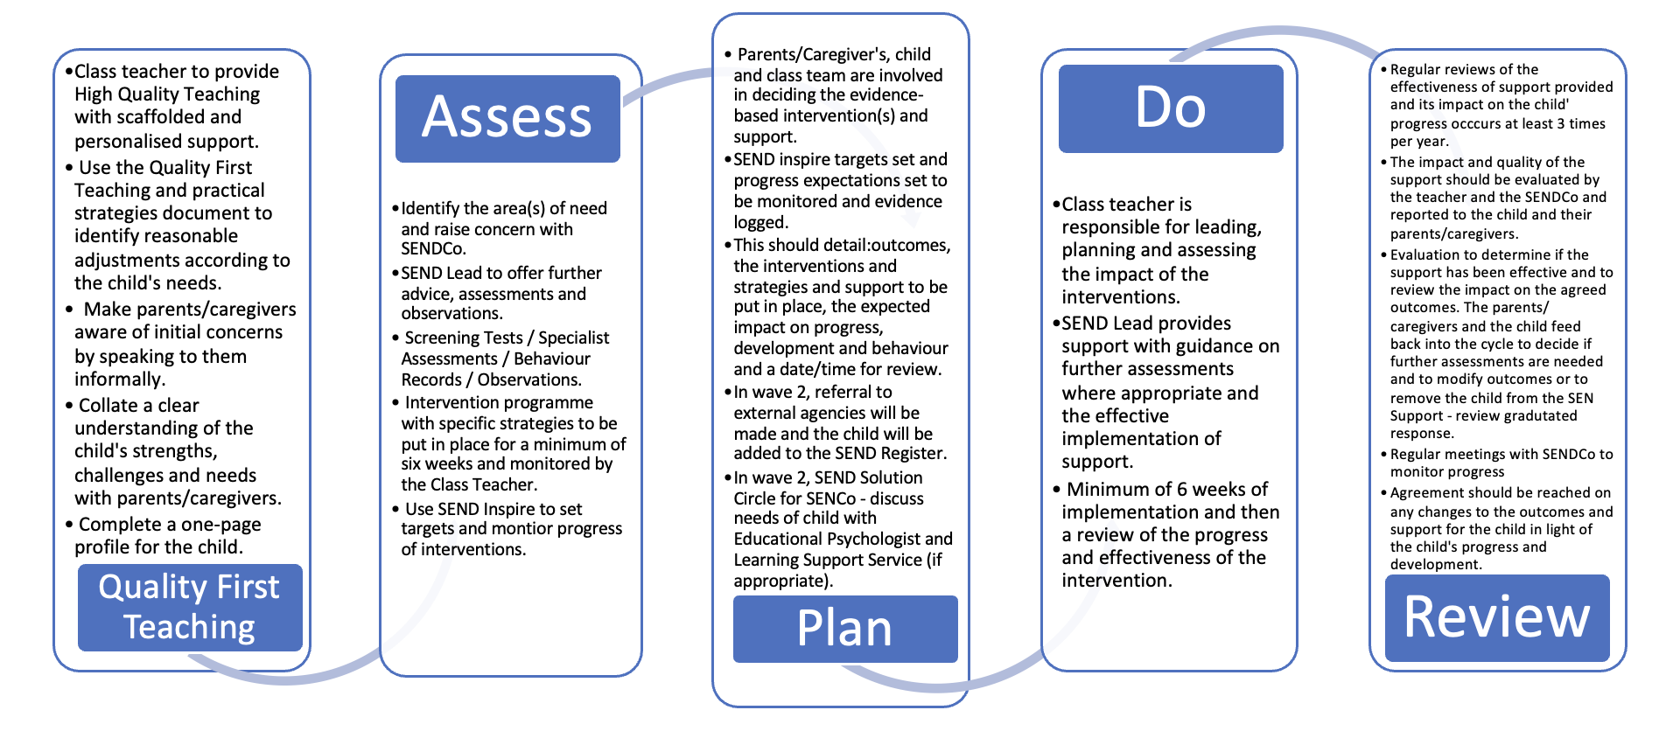
Quality first teaching is where the teachers use their knowledge of the child to adapt the child’s learning opportunities in order to support their academic progress. This could include:
- Seating arrangements in the classroom
- Resources provided as a part of the learning, such as maths manipulatives or word banks
- Use of visual prompts to chunk and support learning
If these adaptations are not sufficient to support the progress for pupils, the children’s needs are ‘different from or additional to’ the opportunities offered to all pupils in the class. At this point, discussions between the parents and carers, child, SENCo and class team will occur to begin the graduated response cycle. As a result, these children will be added to the SEN register, usually under ‘SEND Support’. Support for these pupils could include:

- Interventions
- Additional adult support in learning
- Access to ICT equipment for learning support
- Sensory breaks outside of the classroom as needed, when recognised by the adults

While the majority of learners with SEND will have their needs met in this way, some may require an Education Health and Care (EHC) needs assessment to determine whether it is necessary for the Local Authority to make provision in accordance with an EHC plan (EHCP) or have an EHCP from a previous setting. Where appropriate, parents may apply for a specialist provision for these pupils. Children with EHCPs have a record of support and an annual review to discuss progress towards their targets.

Broad Categories of SEND
The types of special educational needs, listed under the broad categories of SEN as identified in the 2014 code of practice include:
- Communication and interaction
  - Including autistic spectrum condition and speech and language difficulties
- Cognition and learning
  - Including specific learning difficulties, and moderate learning difficulties
- Social, emotional and mental health (SEMH)
  - Including challenging behaviour linked to social and emotional difficulties, ADHD and attachment disorders
- Physical and sensory needs:
  - Including mobility challenges, visual processing difficulties, auditory processing difficulties

Pupils may have needs across multiple categories of SEN, which are planned for when considering their pathway for learning. Categorisation of need considers the one having the most significant impact on their learning.

Provision for our SEN learners:
Following the SEN Code of Practice (2015), once SEND needs have been identified, a continuous four-part cycle begins, the graduated approach of assess, plan, do, review. The graduated approach is a collaborative cycle to support the pupil with SEND, generated collaboratively with the parent/carer, pupil, class teacher and SENCo, detailed in our SEND policy.

Children with SEN require provision which is ‘different from and additional to’ their peers. This provision is offered through the class teacher planning to meet the needs of the child, as a part of planning for their class, known as scaffolding their learning. This could look like:
- Accessing additional resources
- Accessing adapted learning tasks
- Receiving additional support in their learning
- Receiving small group, evidence-based interventions that continue to be overseen by the class teacher
Children will access a scaffolded version of their year groups’ curriculum, unless working significantly below age-related expectations. In this instance, specific, bespoke learning plans and curriculums will be implemented for their child to ensure progress at a stage-appropriate level.

The SEN provision and offer is overseen by the school SENCo, Kate Sudell, who works to ensure the whole school strategic planning supports children with SEN. This is detailed in the accessibility plan.

For children at Langer Academy and Bramford Lane Hubs the SEN provision is overseen by the Lead Teacher, Rachel Wallace.

Social and Emotional Wellbeing
We recognise that pupil’s mental health, and emotional states significantly impact their ability to engage in school learning. Social and emotional difficulties can often be communicated through challenging behaviours, such as defiance, aggression, self-harm or becoming withdrawn.

All our staff are trained in supporting children with SEMH needs, and are aware of identified needs of pupils within their classrooms. Whilst upholding high expectations of behaviour and engagement with learning, SEMH needs are planned for and accommodated for within the classroom. This could look like:
- Having a meet and greet with a familiar member of staff
- Chunking of the day into manageable chunks
- Social skills interventions such as ELSA sessions
- Sensory breaks away from the classroom
- Motional assessments and interventions
If the progress is not being made towards the targets, we can engage outside services to gain further support for a child. This could be services through Suffolk’s Local Offer, such as the Specialist Education Service, referrals to alternative provisions, speech and language therapists, paediatric services, educational psychologists, primary mental health workers or the school nurse. The school is a member of the Unity Schools Partnership; we benefit from sharing information and resources, networking meetings and the support of the Hub coordinator. We also receive support and advice from our SEND director George Ellis.

Evaluating the effectiveness of the provision
As a part of the graduated response, all provision for SEN pupils is reviewed regularly. Assessments (both formative and summative) monitor the impact of the provision, and decisions are made collaboratively by the parents/carers, child, class team and SENCo as to whether the provision is effective or not. Ineffective interventions are stopped and a new plan to meet the child’s needs is made.
The Headteacher, Hub Lead Teacher, SENCO, the remainder of Senior Leadership Team and the SEN governor work to constantly evaluate and improve our SEND provision. We review the progress made by all children with SEND, then look more closely at the progress made by groups of children in the same year group or with similar needs. This enables us to ensure that we target provision appropriately.

Enrichment Opportunities
The school offers a range of extra-curricular activities, both during and after school. Children on the SEN register are actively encouraged to attend clubs which enable them to learn new skills and to develop confidence.
We endeavour for all children to be involved on school trips and enrichment activities. Risk assessments are completed where appropriate to assess the safety of pupils being offsite, and where appropriate onsite learning activities are presented as the alternative.

Working with parents and carers
Children who are identified as having SEN have individual learning targets set with their individual education plans (IEPs), progress against their targets is reviewed regularly with the SENCo, Class Teacher, children and families.
Opportunities to discuss a child’s SEN can be requested at any point, through speaking to the class teacher, Hub Lead teacher, SENCo, Hub teachers or Headteacher. A meeting will then be scheduled to discuss any concerns, progress and next steps. All families are signposted to SENDIASS, the special educational needs and disabilities information advice and support service, to gain independent advice on their child’s needs.

Funding
Langer Primary Academy receives funding from the Department for Education, some of which is intended to support children with SEN. For children who have particularly high levels of need and support, we apply for top-up funding (High Tariff Needs Funding) from Suffolk. This funding has previously been used to employ additional teaching assistants to work with these high-level need children, to support the funding of alternative provisions for pupils who required intense therapeutical intervention, to fund our additional intervention resources, and purchase resources necessary to support access to learning. The school is accountable for the first £10000 of funding before an application for High Needs Funding can be raised.

The School’s Facilities to support children with SEND
The school is compliant with the demands of the Equalities Act and the Disability Discrimination Act. This means that all areas of the school are equally accessible to all children. Risk assessments are routinely completed for all our children with additional mobility needs and, where necessary, modifications to the school are made. If necessary, the school is often able to secure funding for new or specialist equipment as recommended by a medical professional.
Where appropriate, adults are trained for manual handling to ensure that they know how to support and help children in a manner which keeps both the adults and the child safe.
Complaints Policy
We work hard to support all of our children, but sometimes parents have concerns which they don’t feel are addressed. If you have any complaints, please follow the complaints policy as outlined on our website.

Strategic Management
Below is a list of people who are particularly concerned with the organisation of SEN in the school, all contactable through the school office.
SEND Governor: Stuart Mason
SENCo: Kate Sudell
Headteacher: Jo Morgan-Soane
Hub Lead Teacher: Rachel Wallace

